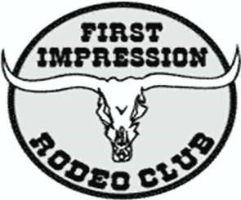
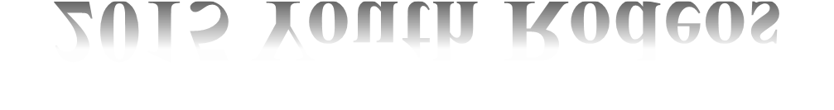
First Impression Rodeo Arena
(Dennison Park)
7003 Coors Rd SW
Albuquerque, NM 87121

2019

YOUTH RODEOS

April 6th & 7th @ 9:00 am

June 1st & 2nd @ 9:00 am
New Mexico Youth Day Saturday, August 3rd @ 9:00 am
FREE ENTRY FEES

Sunday, August 4th @ 9:00 am

October 5th & 6th @ 9:00 am

RODEO EVENTS
6 and Under |  | 7-9 | 10-13 | 14-18 | Open Divisions
Leadline ($5)
Barrels ($10) |  | Barrels ($10) | Barrels ($10) | Barrels ($10) | Team Roping ($25)
Poles ($10) |  | Poles ($10) | Poles ($10) | Poles ($10) | Ribbon Roping ($25)
Flags ($10) |  | Flags ($10) | Flags ($10) | Flags ($10) | Breakaway ($25)
Goat Tapping ($15) |  | Goat Tying  ($25) | Goat Tying  ($25) | Goat Tying  ($25) | Chute Doggin’  ($25)
Steer Dobbin ($25) |  | Steer Dobbin’ ($25) | Steer Dobbin’ ($25) | Steer Dobbin’ ($25)
Mutton Busting’($25) |  | Calf Riding  ($35) | Mini Bull Riding ($55) | Junior Bulls ($65)  Senior Bulls ($75) | FUN HALF TIME EVENTS!  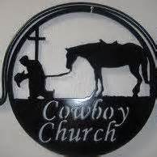  Cowboy Church Sundays before the Rodeo
Stick Horse Race ($5)
Dummy Roping ($10)
REGISTRATION:
Registration, entry forms & payments
First Impression Rodeo Club, Inc.

are to be mailed 2 weeks prior to the Rodeo to:
Kathy Romero
5712 Cambria Rd NW
Albuquerque, NM 87120
(505) 459-2918 Visit our website to download entry forms www.FIRC.Bravesites.com
First Impression Rodeo Club, Inc. is a non-profit organization.

